**Warracknabeal Annual Tournament - Ladies’ Day**

**Nola Clarke Memorial**

**‘Golden Putter’**

**18 holes 4BBB v Par**

**Proudly sponsored by Brian Clarke**

**Friday 7th November 2025**

**8:30am assembly for 9:0am Shotgun Start**

**$50 per pair** (Eftpos available)

**Entries to Women’s Captain Julie Bayles by NOON *Thur. 6th November***

m. 0428 324455 e. julie@powerandbennett.com.au

(names, golf link numbers, home clubs, if you’re using/sharing a cart, phone & email)

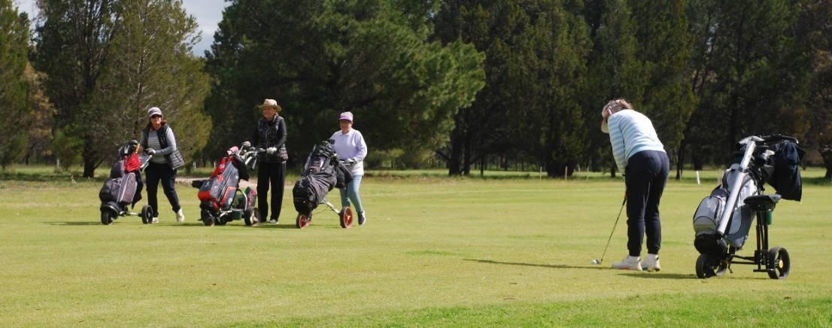

**NEW DATE**

**Contact Captain Julie about CART AVAILABILITYand FREE CAMPING ONSITE**