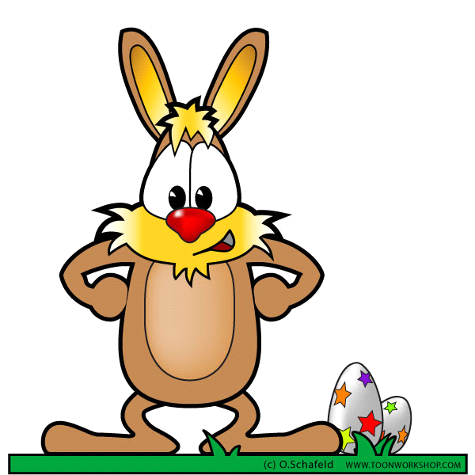

warracknabeal easter FESTIVAL WARRACKNABEAL gOLF CLUB
EASTER GOLF
Fri 3rd & MoN 6th April 2026
18 watered, grassed fairways & greens

Fri. 3rd April | Men’s & Women’s Stableford | Sponsored by Warrack HOME Timber & Hardware | $15pp
Sat. 4th April | Regular Saturday golf – Stableford
Mon. 6th April | 4BBB S’ford  Any Combination | Sponsored by Drummond Golf  Ballarat | $15pp
Enter on the day.

Tee off times for events:
Mornings before 9:30am or afternoons between 12:00pm & 12:30pm

Box office will be attended by a member at 11:30am. (Morning golfers to record their name on the sheet provided & post their entry fees in the Green Fees slot in the wall)

Bar open for drinks & hot food:
Friday: 4:00–6:30+pm
Mon: 11:40am–1:00pm & 4:00pm–7:00pm

Presentations at approx. 5:30pm

Any queries to Captains:
David Flannery 0472610806 Julie Bayles 0428 324 455

Green fee & social golfers welcome over the Easter break any time.

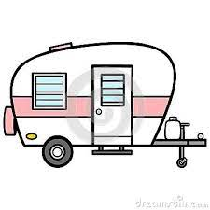
Contact a Captain about cart availability and FREE on-site camping for players……..

Find out more about golf in Warracknabeal or other events in the Warracknabeal Easter Festival on Facebook.
Music, horse races, Sat. parade, museum, dog park, street market, show n shine, art, kids activities & much more.

