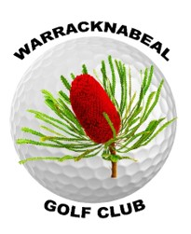

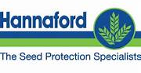

ANNUAL TOURNAMENT - MEN’S DAY
Hannaford UPL
‘Golden Putter’
36 holes 4BBB v Par

FIRST PRIZE
Scotty Cameron Putters
Saturday 14th November 2026

7:30am assembly for 8:00am Shotgun Start
$60 per pair (Eftpos available)
BBQ lunch included.
Entries to Men’s Captain Dave Flannery by Friday 13th Nov, 12 noon.
m. 0408 598 492 e. ashbpurdue@gmail.com
(names, phone, golf link numbers, home clubs, if you’re using/sharing a cart)
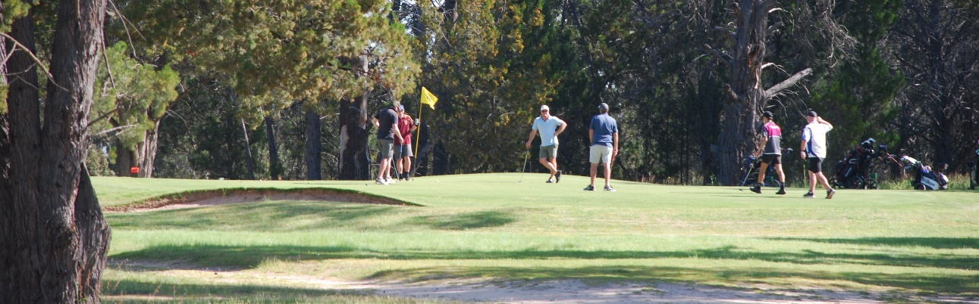

Contact Captain about CART AVAILABILITY and/or FREE RV sites ONSITE
throughout the Nov 12-15 tournament

More information about the Annual Tournament on Warracknabeal Golf Club website & Fbk.

